Co-Chair  Vernon Sykes, Representative  34th House District | 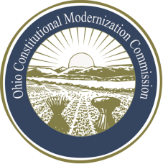 | Co-Chair  William G. Batchelder, Speaker  69th House District
Ohio Constitutional Modernization Commission

Liaison with Public Offices Committee
Herb Asher, Chair
Thursday, June 13, 2013

Chairman Asher called the first meeting of the Ohio Constitutional Modernization Commission Liaison with Public Offices Standing Committee to order at 1:34 p.m. A quorum was present.

The Chairman asked the members of the committee for input on what the role of the committee should be, noting that informing public officeholders on the commission’s work will overlap with some of the work of other committees, as well as the full commission.

Governor Taft mentioned the unique perspective that statewide officeholders would have on potential changes to the constitution. Senator Skindell said that the committee could work with various organizations made up of public officeholders, as well as contact officials in large counties and cities.

It was suggested that the committee actively reach out to public offices of various levels within the state through the use of letters, e-mails, presentations and other tactics, and encourage them to provide input to the commission.

Chairman Asher asked that the committee contact the various organizations and collect information on when their meetings with officeholders are held so that a member of the Liaison with Public Offices Committee can attend them on the commission’s behalf. He also suggested writing a separate letter to major municipalities. Senator Skindell mentioned that it would be important for the committee to help current officeholders get out word of the commission to their constituencies that already exist.

Herb Asher, Chair | Robert Taft, Vice Chair
With no further business, the committee adjourned at 1:58 p.m.

